DESCRIPTION OF THE AFFECTED ENVIRONMENT CHAPTER 4

This section of the Scoping Report provides a description of the environment that may be affected by the proposed Mokopane Integration Project Transmission Lines. This information is provided in order to assist the reader in understanding the possible effects of the proposed project on the environment. Aspects of the biophysical, social and economic environment that could be affected by, or could affect, the proposed development have been described. This information aims to provide the overall context within which this EIA is being conducted. A more detailed description of each aspect of the affected environment is included within the specialist scoping reports contained within Appendices ?? to ??.

Location and Overview of the Study Area

The proposed transmission power line corridors are located within the Lephalale (LIM362) and Mogalakwena Local Municipal areas. Both these local municipalities are located within the Waterberg District Municipality (DC36) of the Limpopo Province.

Lephalale Local Municipality
Mogalakwana Local Municipality

Figure 4.1: Delineation of the Lephalale and Mogalakwana Local Municipalities within the Waterberg District Municipality

The study area is situated approximately between the towns Lephalale in the west and Polokwane in the east. The greater study area contains elements of both grassland and woodland, but the proposed alignments are situated largely within woodland. The area is situated within the Limpopo catchment area. Numerous rivers and drainage lines are crossed by the various alternatives. The proposed corridors cross landform types ranging from plains in the north to a number of areas consisting of hills and mountains in the south.

The land use within the study area consists of mining and commercial farming with a mixture of game, cattle and crop cultivation – both dryland and irrigation. Sections of the study area contain subsistence farming, with a mixture of cattle and crop cultivation. The study area includes a number of conservation or protected areas (both provincial and private nature reserves) as well as the Waterberg Biosphere Reserve core, buffer and transitional zones. Industrial and mining land uses occur west of Lephalale in the form of the Groottegeluk coal mine, and the two Eskom coal-fired power stations (the existing Matimba Power Station and the Medupi Power Station currently under construction). Platinum mining activities takes place north-west of Mokopane between the R518 and the N11 national road.

Large tracts of land within the study area are still in a natural state (undisturbed) with some areas in and along the Waterberg escarpment in a virtually pristine condition. This is due mainly to the low population density (less than 10 people per km²) of the Waterberg plateau and escarpment and the relative remoteness and inaccessibility of the terrain. The population density increases eastwards with a great number of settlements occurring along the Mogalakwena River (between the R518 and N11). Here the population density is between 100 to 200 people per km² and 50 to 100 people per km² east of the N11

A number of properties are potentially affected by the proposed alternative transmission power line alignments. These are owned by either private landowners or Traditional Authorities.

Social Characteristics of the Study Area

The Waterberg District Municipality (WDM) is made up of six separate local municipalities, including the Mogalakwena and Lephalale Local Municipalities (see Figure 4.1). The WDM is the largest of the six districts and lies to the west of the Limpopo Province. The district is mostly rural in nature and, according to the Community Survey 2007, has a total population of approximately 596 092 people living in 160 720 households (at an average of 12 people per km², much lower than the average provincial density of 40 people per km²⁾.

In a 2007 Community Survey, the unemployment rate within the district was estimated at around 29.0%, which was much lower than that of the province. Furthermore, approximately a third (33.0%) of the district’s population was under the age of 14 years, which would make any job opportunities vital to the future development of the district.

The WDM is characterised by discrepancies in wealth and skills. The majority of households earned an annual income below R18 001 in 2001. Households’ production levels are declining leading to a situation where the majority of the population are financially dependent on state pension and social welfare grants as their primary source of income and subsistence. This is linked to the low educational levels, and lack of skills.

The Waterberg District Municipality’s (WDM) Integrated Development Plan (IDP 2008/09) states that only approximately 0.43% of the district’s total land surface area is used for settlement purposes (i.e. towns and villages). Of these towns and villages, by far the majority (approximately 69%) are located within the Mogalakwena Local Municipality’s area of jurisdiction. In Lephalale Local Municipality, only 37% of the population lives in settlements with high population concentrations and growth potential. The urban areas such as Mokopane and Lephalale dominate the district’s urban settlement pattern.

A large portion of the eastern section of the study area falls within tribal land, i.e. land belonging to a Tribal Authority. Tribal Authorities identified through the public participation process include: Laka, Shongoane, Seleka, Lekalakala, Bekenburg, Mapela, MokopaneDikgale, Moletsit, Bakone, Maraba and Mashashane Traditional Councils.

Demographic Profile

The Integrated Development Plan of Lephalale Local Municipality envisaged that the total population for Lephalale Municipality will increase from 80 141 to
106 521 in 2010. The estimated future population of Lephalale Municipality will increase with approximately 6 500 people over the next 6 years (from 2007). It was estimated that the population growth rate for Lephalale Municipality will decrease from approximately 1,345% in the year 2004 to 1,024% in the year 2010.

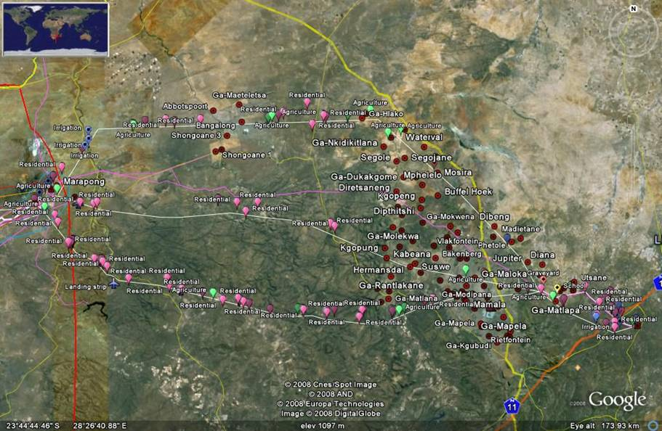
Figure 4.2: Settlement and development patterns with the study area
Despite its beneficial location in terms of international trade, the Limpopo Province is regarded as one of the poorest provinces in South Africa. In the province there is an almost equal split between the employment and unemployment rate of the economically active population, with 59.6% being employed in 2007. Of those employed, 18.4% are employed within the community services sector source.

Economic Profile

The Waterberg District Municipality Integrated Development Plan (2008/09) states that the key economic sectors within the WDM are mining, electricity/water, services, trade/catering and agriculture, with mining making the biggest contribution to the Gross Geographical Product (GGP). The land use pattern is fairly natural within the district, with most of the mining operations concentrated on the periphery, whereas the central area is mostly characterised by the tourism and game industry. The tourism industry is also a significant contributor to the Gross Domestic Product (GDP). Similar to the province as a whole, a trend in the area is the conversion of agricultural land into game farms resulting in a rapid expansion of game farming and tourism in the area. The WDM is malaria free and has a rather mild climate that adds to the district’s appeal as a tourist destination. The area is also in fairly close proximity to the Gauteng Province which makes it not only an appealing destination, but also a prime location to develop game farms.

Field cropping and animal production are the main activities in the study area. During recent years game farming has become a major economic activity in the area and this upsurge in eco-tourism and commercial hunting lead to a decrease in traditional agricultural activities. It is likely that game farming activities will increase. The assumption was therefore made that the grazing portions identified along the corridors are for the purposes of game farming.

Extensive mining reserves of the platinum group metals and ferrochrome reserves are present within the study area, which have given rise to extensive mining activities. It is expected that mining, electricity/water, services, and trade/catering will increase in future due to the Matimba Power Station which is located in Lephalale.

Figure 4.3: Land uses within the study area

Socio-Cultural Profile

Four archaeological or heritage zones can be distinguished in the Mokopane Integration Project Area considered from an ecological, historical and pre-historical perspective. These are:

- the plains to the west of Polokwane and Mokopane which are dotted with scattered mountains, kopjes and knolls across a vast plain;
- the Waterberg mountain mass in the central part of the study area;
- flat outstretched bush and sand veldt to the west of the Waterberg mountains and a number of isolated flat-topped hills (mesa) and
- kopjes in thorn-veldt in the north-western part of the study area.

The plains towards the west of Polokwane and Mokopane are characterised by a number of large mountains and smaller kopjes and knolls. Some of these mountains, further towards the west, near the Potgietersrust Platinum Mine, bear historical names such as Mapela, Masenya, Tshaba and the historically well-known Fonthane. These mountains serve as historical beacons outlining the spheres of influence of the Langa-Ndebele, a Nguni group who settled in this area during the sixteenth and seventeenth centuries. The Ledwaba/Maune Ndebele clans, who are related to the Langa-Ndebele, live in the Bergzicht-Kalkspruit and Mašašane townships. Corridor 3 for the proposed 765kV power lines traverse these historical Ndebele spheres of influence.

The extensive Waterberg mountain mass in the central part of the study area covers the largest part of the project area. This mountainous terrain is divided by both the Mogol and Magalakwena Rivers which runs from the south to the north through this mountain range. No dense concentrations of archaeological or other heritage sites have yet been recorded in this eco-zone. However, krantzes and ridges along the northern and southern escarp of this part of the project area, as well as valleys that criss-cross the mountain range, harbour some rock paintings. Caves and rock shelters also occur where Stone Age hunter-gatherers established semi-permanent settlements, particularly during the Middle Stone Age. Corridors 2 & 3 traverse the Waterberg mountain range.

On the far western extremity of the Waterberg, after passing the last foothills in this range, open sand veldt covered with thorn trees marks the Mokopane Integration Project Area. This land was formerly the sphere of influence of the pre-historical San and historical Vaalpense who roamed the area in small family groups acting as nomadic hunters and herders. Early Iron Age farmers also lived near the western perimeter of the Waterberg where they herded cattle, possibly practised limited crop planting but smelted iron on a substantial scale at the site of Diamand. Corridor 3 traverses the western edge and foothills of the Waterberg mountain range.

Isolated kopjes and flat-top hills (mesa) in thorn-veldt occur across the north-western part of the Mokopane Integration Project Area where these topographical features corresponds with the northern perimeters of the spheres of influence of the Seleka-Ndebele and the Batlhalerwa (Shongwane). Both these clans have their origins in the Late Iron Age and historical periods. The Shongwane originate from Zimbabwe and settled in the far north-western corner during the 18th century. They are historically associated with Nora and Bobididi, two of the flat-topped hills in the area. In this far north-western part of the study area these communities practised farming and metal working, the remains of which still occur in the area. Corridor 3 runs slightly to the north of these flat-topped hills, isolated kopjes and krantzes where the Seleka and Shongwane lived.

Mokopane and Polokwane in the east of the study area represent two of the oldest colonial towns in the former Transvaal Province. This area incorporates the plains with granite hills to the west of Mokopane, which, was also home to the Ndebele tribes of Kekana and Langa. These clans occupied places such as Maraba, Masasane and Vaaltyn to the north-west of Mokopane. Lephalale in the west is much younger being established as a result of the area's importance in coal reserves.

Each of the eco-zones identified is therefore associated with human groups from the past. Descendants of these populations, such as the Ndebele, Vaalpense, colonials and Shongwane still live and work in the area and can be found in towns and villages in or close to the Mokopane Integration Project Area.

Biophysical Characteristics of the Study Area

Geographical Profile

Situated on a plateau 1 312 m above sea level, the Limpopo Province has warm to hot summers with moderate winters. It has an average annual rainfall of between 577 and 1 000 mm. Average summer temperatures rise to approximately 28°C and drop to around 17°C. Average winter temperatures range from 4.7°C to 19°C. Average rainfall and temperatures rise in the lowveld areas of the Province.

The study area covers a considerable piece of land in the Limpopo Province as it runs from the Delta Substation near Lephalale in the west across the Waterberg mountain range to the Witkop Substation near Polokwane and Mokopane in the east. Most of the study area comprises areas of natural habitat, including Thicket, Bushland and Woodland. The eastern part of the study area is characterised by moderate transformation and extensive areas of cultivation and degraded woodland (Figure 4.4).

Figure 4.4: Landcover of the study area showing different transmission line corridors.
The proposed power line corridors cross landform types ranging from plains in the north to areas consisting of hills and mountains in the south. These hills and ridges are especially important since they are likely to sustain populations of conservation important invertebrate species.

The dominant vegetation type found within the study area is woodland, i.e. Arid or Moist woodland. The woodland biome covers most of the northern and eastern sections of southern Africa. Woodland is defined as having a grassy under-storey and a distinct woody upper-storey of trees and tall shrubs. Arid woodland comprises predominantly fine-leaved, semi-deciduous Acacia-dominated woodlands on rich soils. This vegetation type occurs where there is intermediate, though variable, rainfall with hot, wet summers and cool, dry winters. Moist woodland comprises predominantly broadleaved, winter deciduous woodland. Soil types are varied but are generally nutrient poor.

The majority of the northern and eastern parts of this study area are in a state of transformation, with a number of settlements dotted throughout the immediate surrounds intermingled with mining areas and both commercial and subsistence forms of cultivation. As a result, a great deal of the vegetation within most of Corridor 2 has and is being transformed. The habitat in the area has been subjected to severe pressure from the neighbouring communities and the various land use types.

Ecological Profile

Some areas within the study area have known importance in terms of floristic and faunal attributes (refer to Figures 4.5 and 4.6). These areas frequently exhibit characteristics of a pristine nature, the presence of Red Data flora species, a high diversity or atypical or threatened vegetation types and habitat types. The following VEGMAP vegetation units are present within the study area:

- Central Sandy Bushveld;
- Limpopo Sweet Bushveld;
- Makhado Sweet Bushveld;
- Mamabolo Mountain Bushveld;
- Polokwane Plateau Bushveld;
- Subtropical Alluvial Vegetation;
- Waterberg Mountain Bushveld

The conservation status of the different vegetation types occurring in the study area is listed below in Table 4.1.

Table 4.1: VEGMAP Conservation Status
VEGMAP Unit | % Conserved | % Transformed | Target | Status
Central Sandy Bushveld | 3% | 24% | 19% | Vulnerable
Limpopo Sweet Bushveld | <1% | 5% | 19% | Least Threatened
Makhado Sweet Bushveld | 1% | 27% | 19% | Vulnerable
Mamabolo Mountain Bushveld | 8% | 6% | 24% | Least Threatened
Polokwane Plateau Bushveld | 2% | 17% | 19% | Least Threatened
Subtropical Alluvial Vegetation | 71% | 16% | 31% | Least Threatened
Waterberg Mountain Bushveld | 9% | 3% | 24% | Least Threatened

A number of nature reserves other key conservation areas were identified in the study area (Refer to Figure 4.7), including, inter alia, the D’Nyala Game Reserve, Kwalata, Lapalala Nature Reserve, Touchstone Nature Reserve, Moepel Farms, Shelanti Game Ranch, Keta Cattle Game Project, Witvinger Reserve, Shayamanzi Red Leopards Project, Percy Fyfe Nature Reserve, Kuschke Nature Reserve, Wit Vinger Nature Reserve, and the Waterberg Biosphere Reserve.

The Waterberg Biosphere Reserve (Figure 4.8) was officially established in April 1990 with the aim to maximise the Waterberg area’s potential for conservation, sustainable development and social upliftment. A key aspect in the formation of the Biosphere was the formation of partnerships amongst all the stakeholders who share the area, ranging from privately owned reserves and game farms, to tribal and state owned areas such as Moepel farms. The total reserve is approximately 14 500 km², with an estimated 6 people per km². The area was mostly characterised by cattle and crop farming, but during the past 15 years there has been a gradual shift in land use to that of conservation and the sustainable use of wildlife ranging from tourism and eco-tourism to hunting.

Woodland habitat, in its undisturbed state, is suitable for a wide range of birds. With the presence of river systems and numerous agricultural fields, the study area is considered to be particularly attractive to many species of birds. The Southern African Bird Atlas Project recorded a total of 30 Red-Data bird species across the study area. In addition, the White Stork and Abdim’s Stork (Protected internationally under the Bonn Convention on Migratory Species) are considered as a threatened species for the purpose of this study. Several of the Red Data species recorded here are known to be extremely vulnerable to the impacts of power lines, through collision.

Figure 4.5: Areas of Faunal Importance in the study area

Figure 4.6: Areas of Botanical Importance in the study area

Figure 4.7: Formal conservation areas identified in the study area

Figure 4.8: Biospheres in the study area

